Name:______________________________________ Date: ____________ Period: ____
Lesson 2.2.3 Homework Problems 2-62 to 2-66
2-62. Sketch each expression using + and – tiles or draw it on a number line. Then find the simplified value of each expression.
a. −5 + 6 + 4 b. 7 + (−3) + (−4)

c. d.

2-63. What happens if Cecil goes any number of feet in one direction and then goes the same number of feet the other direction? Where does he end up? How do you know?

2-64. John has a bag of marbles that contains 12 red marbles, 20 green marbles, and 17 blue marbles.
a. If John pulls one marble out of the bag, what is the probability that it will not be red? That is, P(not red)?

b. What is the probability that he will draw a purple marble? That is, P(purple)?

2-65. Find the missing lengths in the problems below. Assume each line segment is subdivided into equal segments. Show your work.
a. 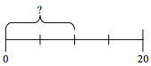 b. 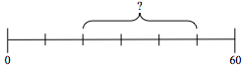

2-66. On Saturday, Stella worked for two hours helping her mother around the house. She spent of her time doing laundry, of her time cleaning, and the rest of her time working in the yard. How much of her time was spent in the yard? Show all of your work. Use a diagram if it helps.

